TWENTY FOURTH SUNDAY AFTER PENTECOST November 16, 2025
Prairieland Parish
As we unite in worship today, we extend a warm welcome to each one present. May we together experience the presence of God
+++++++++++++++++++++++++++++++++++++++++++++++++.
We Gather to Prepare Our Hearts to Meet Our Lord

Prelude
Welcome
Announcements

Call to Worship
The world is filled with the glory of God, and we say,
Thank you!
The hills and valleys are filled with color, and we say,
Thank you!
The vines and trees are filled with fruit, and we say,
Thank you!
Our tables are overflowing with food, and we say,
Thank you!
Our life is filled with love of family and friends, and we say,
Thank you!
We fill this house of God with our voices, saying,
Thank you!
May the words of our mouths and the meditations of our hearts
be acceptable to you, O God, as enter into this service of thanksgiving and praise.

Opening Prayer
What mighty praise belongs to You, O God, for Your acts of love and faithfulness toward us! In Your mercy You hear our prayers, You forgive our sins, You provide for our needs.

From one end of the earth to the other, You inspire worship and praise! Even nature celebrates Your goodness.

Receive our adoration, our confession, our thanksgiving. Through the power of Your Holy Spirit make Your presence known among us that we may hear Your Word and know Your will. In the name of Jesus Christ, we pray.

Praise Hymn UMH #89. “Joyful, Joyful We Adore Thee”

We Hear God’s Word
New Testament Reading…………………………………… Philippians 4:4-9
The Word of God for the People of God, Thanks be to God!

CHILDREN’S SERMON

Faith Hymn #92 “For the Beauty of the Earth” (verses 1, 3, 5)

“Message”
Joys/Concerns

Prayers of the People
Lord’s Prayer

Offertory
Doxology

Offertory Prayer

Departing Hymn UMH # 98. “To God Be the Glory”

Benediction

Postlude

November Prairieland Parish Events

Annual Charge Conference

A Cluster Charge Conference on:
Date: Tuesday, November 18th
Location: United Church of Grand Meadow
Time: 7:00pm
All Church leadership is encouraged to attend
+++++++++++++++++++++++++++++++++++++
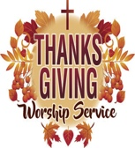
Prairieland Parish wide Worship Service Opportunity

Hosted by: Zion UMC, Sargeant, MN

Date: 26^{th.} Time: 6:30pm
All are invited to come and give thanks to the One whom has blessed us in so many ways!
++++++++++++++++++++++++++++++++++++++++++++
Advent Begins on Sunday, November 30th
Each week readers from the congregation will start with a liturgy of advent
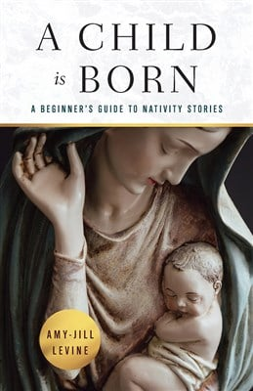
++++++++++++++++++++++++++++++++++++++++++++

Prairieland Parish
Is joining Together for a 4-week book study titled:
“A Child is Born” by Amy-Jill Levine
We will meet in-person Tuesday’s @ 2 pm
@ United Church of Grand Meadow
December 2nd, December 9th, December 16th, December 23rd
++++++++++++++++++++++++++++++++++++++++++
Zoom Study Opportunity
to be led by Bishop Lanette Plambeck
In this study, United Methodists across the Dakotas and Minnesota will gather via zoom on Monday Evenings with Bishop Lanette
Weekly discussions will be held via Zoom on Monday evenings,
Dec 1st-Dec. 22nd, 7-8:15 p.m.

The Zoom link will be provided @ minnesotaumc.org as the first discussion date draws near
You may go on-line to purchase your own book or reserve a book with Pastor Jon or Bridget for $14.00



